*Q2)*

Find the DOF using Grubler’s formula

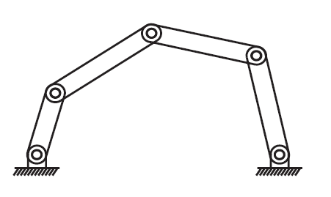

N = 5

J = 5

DOF = 3\*(5-1-5) + 5 = 2